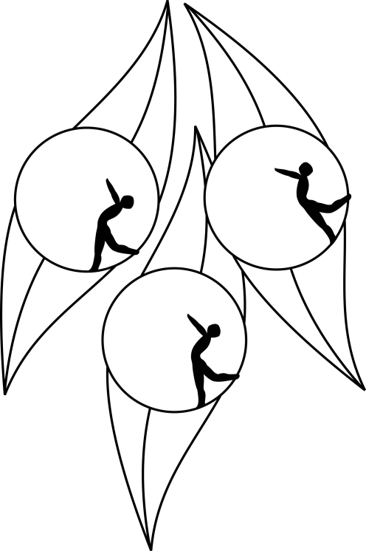
SOUTH AUSTRALIAN ICE SKATING ASSOCIATION Inc.

RESULTS

TEST SESSION

21 February 2010
Ice Arena, Thebarton

Congratulations to the following skaters

Elementary 1:
Alyce Naylor
Arielle Jennings

Elementary 1 Figure Pattern:
Natasha Colliver
Giuseppe Triulcio

Preliminary:
Elysha Glaser

